Turkey Pie Orders Ready: If you have not received your turkey pie orders please see Sue Trenhaile or Cathy MacKendrick about those pies. They are ready. Guess what? We have extra small turkey and small tourtiere pies available for the bargain price of $5.00 each.

Annual Vestry Meeting - Sunday, February 5, following the 10 am service.

Forward Day by Day – The next issue of this daily bible reading and reflection booklet is available on the table in the Narthex.

St. Matthew’s Cookbook – Something good is cooking: Our “2017 St. Matthew’s Church Cookbook.” We would like recipes from as many St. Matthew’s families as possible. Remember to edit recipes and use your own words to avoid copyright issues. Please submit all your recipes TODAY to Sue Bernard, Sandra Hall or Irene Savva, or send toirene.savva3691@gmail.com as soon as possible, and no later than Tuesday January 31, 2017. Thank you!

Saturday February 18 will be our friends and family potluck and games night in the hall. The fun begins at 5 pm with dinner, games to follow. Come join in this fun filled evening of fellowship and laughter. Remember to bring your favourite game and your favourite friend! Any questions, call Jen 519-948-1457.

Sunday February 12 the Sunday School will be making sugar cookies in the kitchen for our shut ins and for Street Help for the homeless. We would appreciate some sugar cookie dough and any heart cookie cutters as well as a few extra hands. Please let Jen or Janet know.

St. Matthew’s Church, Windsor, Ontario
"We are called to share God's love
as we welcome and care for our community"
www.saintmatthewswindsor.ca (519)969-1510

January 29, 2017

The Fourth Sunday after Epiphany

Presiding Celebrant: The Rt. Rev’d Linda Nicholls
Priest: The Rev’d Andreas Thiel
Deacon: The Rev’d Cathy MacKendrick
Pastoral Musician: Michael Ricketts

Prelude: Allabreve (J. S. Bach)
Processional: # 323 Ye Holy Angels Bright
Collect of the Day
Proclamation of the Word

First Reading: Micah 6: 1-8

Psalm # 15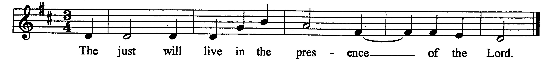
Second Reading: 1 Corinthians 1:18-31
Gospel: Matthew 5: 1-12
Homily
Anthem: We Are Called (Haas-Hayes)
Apostles’ Creed ..................................................................... p. 189

Prayers of the People Response: Lord, hear our prayer
Confession and Absolution …………………………………. p.191
The Peace
Celebration of the Eucharist
Offering Hymn: Bk 1, #6 Here I Am, Lord

The Great Thanksgiving
Eucharistic Prayer: #2 ……………………………….……... p. 196

The Lord’s Prayer
Breaking of the Bread: #6 ………………………….………p. 213
Presider: We break the bread of life,
And that life is the light of the world.
All: God here among us,
light in the midst of us,
bring us to light and life.
Communion Procession Within the Reign of God (M. Haagen)
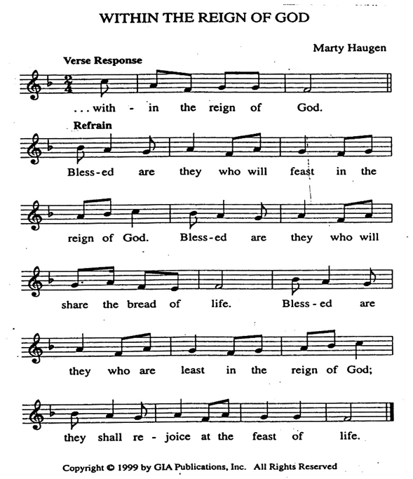
Reproduced under Onelicense net #A-706090. All rights reserved

Prayer after Communion and Doxology.……………………..p.214
Episcopal Blessing
Presentation of Thanks – Becker Engineering Group
Parish Announcements
Recessional Hymn: # 602 Lift High the Cross
Postlude: Concerto in A Minor, Allegro (Vivaldi-Bach)

The flowers in the Sanctuary are given to the glory of God in thanksgiving for Bishop Linda Nicoll’s ministry
among us by Anya and Andreas Thiel.

Welcome visitors – We are blessed you are with us. Please let us know how we can serve you. If you desire, there are “Visitor’s envelopes” on the table in the narthex (foyer) for your use.

Scheduled Ministers for Today's Liturgy:
Cantors: Nicole Sussesn, John Rossi, Margaret Kissau
Communion ministers: Vicky Paraschak, Doug Warford, Louise Davis Lectors: Margaret Kissau, Robert Weir
Servers: Matt Bulley, Alyson Pidhorseky, Eddie McCabe
Intercessor: Jean Muhleisen Collection supervisor: John Rossi
Sidespersons: Chuck Boyd, Flora Smith, Kim MacKendrick
Fellowship Ministers: Cora and Bob Braidford

Marlborough Breakfast Programme: Diane Iannicello, Scott Richie, Cathy MacKendrick Muffin Maker: Sunday School

Scripture readings for Sunday, Febrauary 5, 2017: Isaiah 58: 1-9a; Ps. 112:1-9 (10); 1 Corinthians 2:1-12; Matthew 5: 13-20

Would you like a pastoral visit? – Please contact Rev'd Andreas (519-969-1510, church; 226-345-5085, cell) to arrange a convenient time.

People who are ill and/or in hospital – If you know of someone who is in hospital, please let either Rev’d Andreas or Rev’d Cathy (519 966 5729) know so that they might have a pastoral visit.

