Scheduled Ministers for Today's Liturgy:

Cantors: Nicole Sussens, Carol Caverzan, John Rossi
Server: Trumpet: Beth Felet
Lectors: Doug Warford, Jen McAlpine Intercessor: Jen McAlpine
Communion Ministers: Alisa Yednoroz, Cora Braidford, Andy Hahn
Collection Supervisor: John Rossi Sidespersons: Pat Lown, Flora Smith, Megan Smith, Gail Henderson
Marlborough Breakfast Team: Brayden Ritchie, Janice Johnson, Cathy MacKendrick Muffins: Bev Chantler

Would You Like a Pastoral Visit? – Please contact Rev'd Andreas (519-969-1510, church; 226-345-5085, cell).

People Who Are Ill and/or in Hospital – If you know of someone who is in hospital, please let our clergy or churchwardens know so that they might have a pastoral visit.

Outreach Ministries – Remember your gifts to Hiatus House, our Food Cupboard, the Marlborough Breakfast Program, and the ministry to the Southwest Detention Centre

Rev’d Andreas’ trip to Palestine/Israel – special offering envelopes are available on the table in the Narthex. (See latest edition of ‘The Journey’ for more information.)

Forward Day by Day (daily devotional) – the newest edition is available in the Narthex/Foyer (small donations are appreciated)

3rd Quarter Financial Snapshot – Year to date donations: General & Apportionment, $104,492 (vs. budgeted amount $102,524). Amount owing on Roof Loan, $20,943 (original amount was $65,000). Thank you all for your faithful generosity!

Bishop’s Friends Reception – Saturday, Nov. 30, 7-9 pm, at Amherstburg Malden & Anderdon Sportsmen’s Club. Come and greet Bishop-elect Todd Townshend as well as our Primate, Linda Nicholls. Tickets are $50 per person, and proceeds will benefit the Bishop’s Discretionary Fund. Please speak with Rev’d Andreas if you plan to attend
St. Matthew’s Church, Windsor, Ontario

"We are called to share God's love
as we welcome and care for our community"

www.saintmatthewswindsor.ca (519) 969-1510

November 10, 2019

22nd Sunday after Pentecost

Presider: The Rev'd Andreas Thiel
Deacon: The Rev’d Cathy MacKendrick
Deacon: The Rev'd Glenda Fisher
Pastoral Musician: Michael Ricketts

Prelude: O Worship the King (G. Young
Processional: No Matter

No matter who, no matter what,
No matter where we are on the journey of life;
God calls us, calls us to this place.

No matter who, no matter what,
No matter where we are on the journey of life;
Accepted, welcomed by God’s grace.

Words and Music: Roger P. Miller. Copyright 2007 Sing! Prayer and Praise.
Used by permission. CCLI #11392265

Gathering of the Community …………………………….. p.185
Hymn of Praise: #398 Let Us With a Gladsome Mind
Collect of the Day…………………………………………p. 391
A word about the Word
Proclamation of the Word
First Reading: Job 19: 23-27a
Psalm #17: 1-9 …………………….…………………….. p. 720
Second Reading: 2 Thessalonians 2: 1-5,13-17
Gospel: Luke 20: 27-38

Homily
Anthem: Be Not Afraid (R. Dufford)
Be not afraid. I go before you always.
Come follow me, and I will give you rest

Copyright @1975 Robert J. Dufford and North American Liturgy Resources.
Reproduced under Onelicense.net #A-707090. All rights reserved.

Apostles’ Creed…………………………………..………...p.189

Prayers of the People: Response: Hear our prayer

Confession and Absolution: …………………………….. p.191

The Peace …………………………………………………. p. 192

Offering Hymn: # 380 O Worship the King

Celebration of the Eucharist

The Great Thanksgiving

Eucharistic Prayer # 1………………………………..…… p. 193

Holy, Holy, Holy (see insert)

The Lord’s Prayer

Breaking of the Bread: #2 ……………………………..….p. 212

Presider: We break this bread
to share in the body of Christ.

All: We, being many, are one body,
for we all share in the one bread.

Communion Procession: Eat This Bread (J. Berthier)
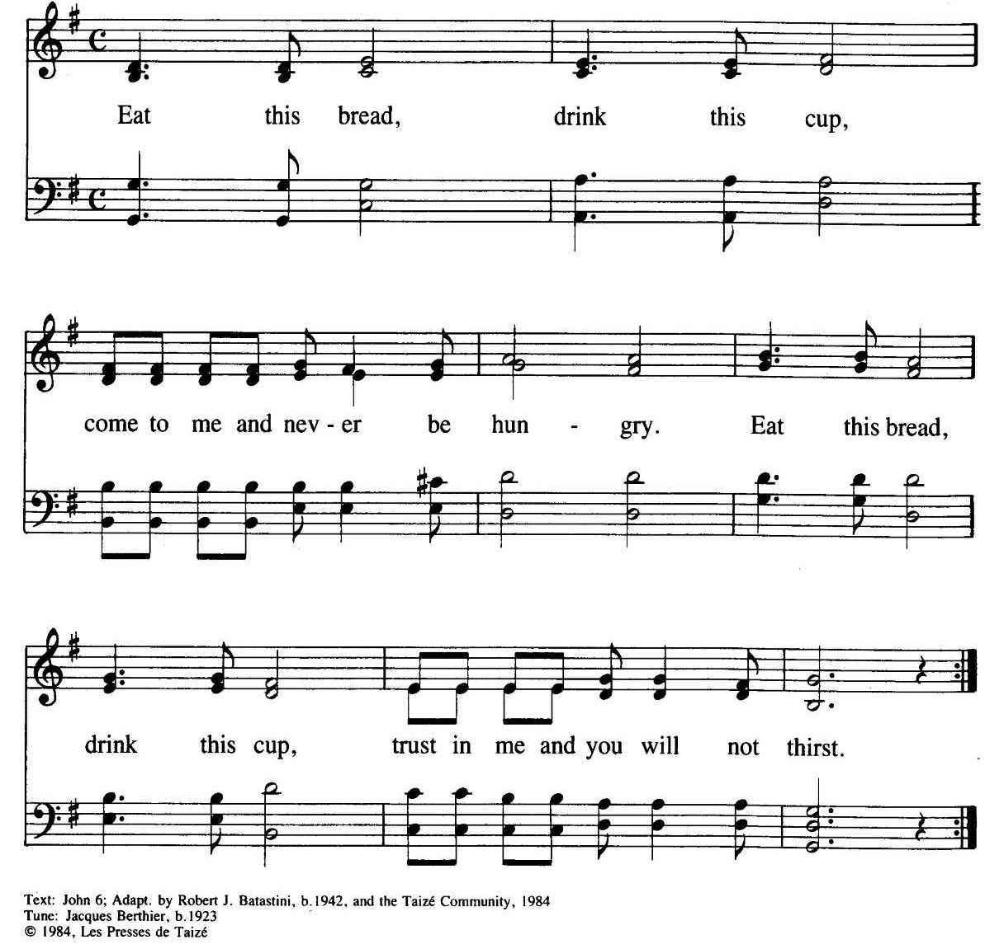
Reproduced under Onelicense.net #A-707090. All rights reserved

Remembrance Day Observance:
Last Post
Reveille
# 659 O Canada
Prayer after Communion & Blessing p. 214
Parish Announcements
Recessional: # 528 O God, Our Help in Ages Past
Postlude: O God, Our Help in Ages Past (G. Young)
* * * * *
Welcome visitors – we are blessed you are with us.
Please let us know how we can serve you. If you desire, there are
“Visitor’s envelopes” on the table in the narthex/ foyer.

The flowers in the Sanctuary are given to the glory of God in memory of Thomas Drake, father of Gordon by Gordon and Mary Lou Drake.

Scripture readings for Sunday, Nov. 17, 2019 –Malachi 4: 1-2a; Psalm 98; 2 Thessalonians 3: 6-13; Luke 21: 5-19

